MOHAMMED ALI S

MECHANICAL ENGINEER

# CONTACT CAREER OBJECTIVE

**Phone: Email :**

+91 9360610811

[aliasiyashakil@gmail.com](mailto:aliasiyashakil@gmail.com)

A highly motivated and disciplined individual searching for a challenging position to discover new areas and to gain work

**Address: 15/9 kumaran nagar 1st street, Thiruvottiyur.**

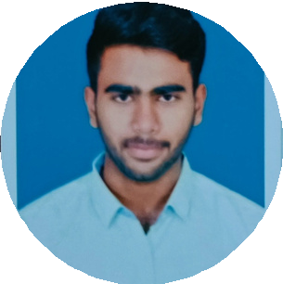

# EDUCATION

2019-2023

Vel tech Multi tech Engineering College Mechanical Engineering

2017-2018

Revoor Matric Hr Sec School Percentage:68.5%

# TECHNICAL SKILLS

Python

SQL, Django MS word, Excel

Type writing

**LANGUAGES KNOWN**

Hindi Urdu Tamil

To Read:Arabic,English

experience from a dynamic organization.

# CERTIFICATIONS

"Workshop on bicycle design" towards Bicycle Design Competition at

N.B.K.R. Institute of Science and Technology. "Internship at MTC" for 8 days

"Full stack development in python" course attended at Shiash Infotech for 3

months

# MANERGIAL SKILLS

Time Management Strong Listening Team player

keen on new technologies

# PROJECTS UNDERTAKEN

BICYCLE WITH IN-BUILT HAND PUMP

Done bicycle with in-built pneumatic hand pump in order to provide the rider a small support when the tire has got puncture. And Won first prize in the innovation category

# DECLARATION

I hereby declare that the above information is correct and true to best of my knowledge

MOHAMMED ALI S